CS 255 System Design Document Template

This template lays out all the different sections that you need to complete for Project Two. Each section has guidance to prompt your thinking. You will need to continually reference the interview transcript as you work to make sure that you are addressing your client’s needs. There is no required length for the final document. Instead the goal is to complete each section based on what your client’s needs are. Remove this note when you are finished, and replace all bracketed text with the relevant information.

UML Diagrams

UML Use Case Diagram
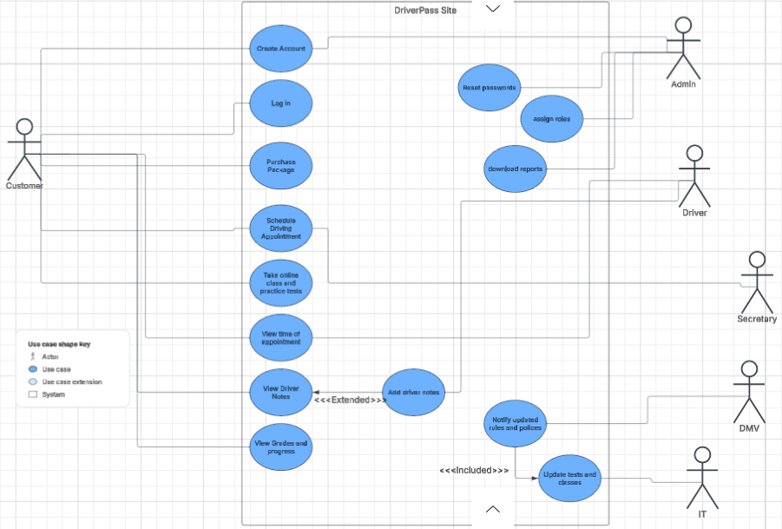

UML Activity Diagrams

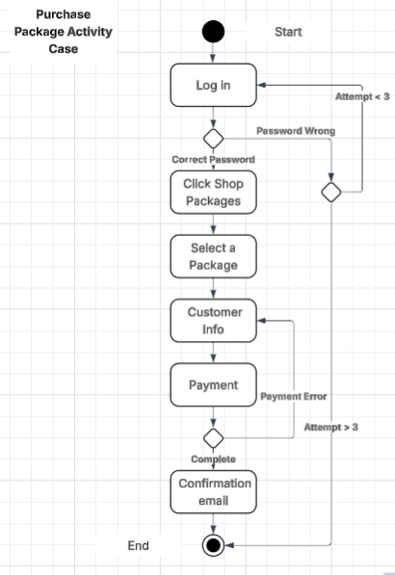
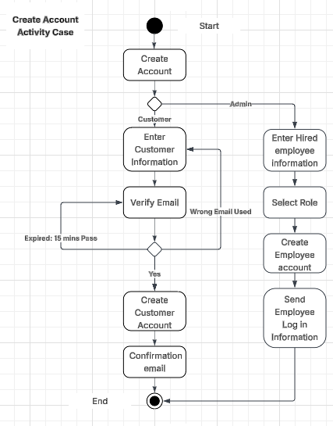

UML Sequence Diagram
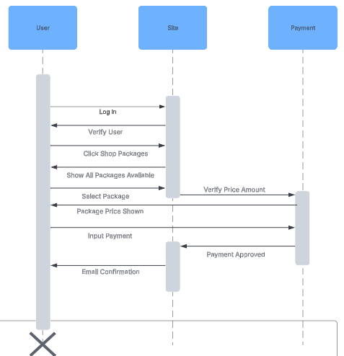

UML Class Diagram
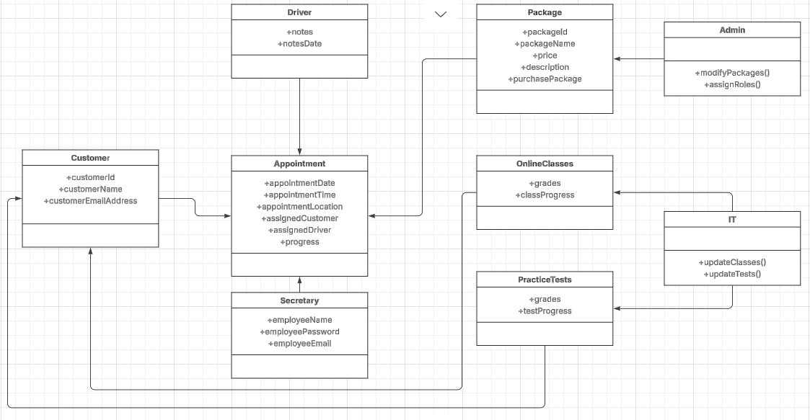

Technical Requirements
The required hardware for this system would be that user will need a computer or a mobile device with internet access to be able to get on the site. The required software for this system should be web-based system so mobile and computer people have access the site. The system should also be cloud hosted system so employees can focus their attention on the customers. Some tools we will using are a login system that has a max three limit attempt on passwords and a role-based access controls so certain users can only access certain data. The system will need a secure database to hold payment information, customer and employee information, and customer information, like class assignments, practice tests, notes, and grades.

